**Linux**:

Linux is a open source s/w which means anyone can modify and do the change according to their requirement

For a company like windows only Microsoft developer can change its s/w so they are called as contributors to windows

But for Linux anyone who uses it are contributors

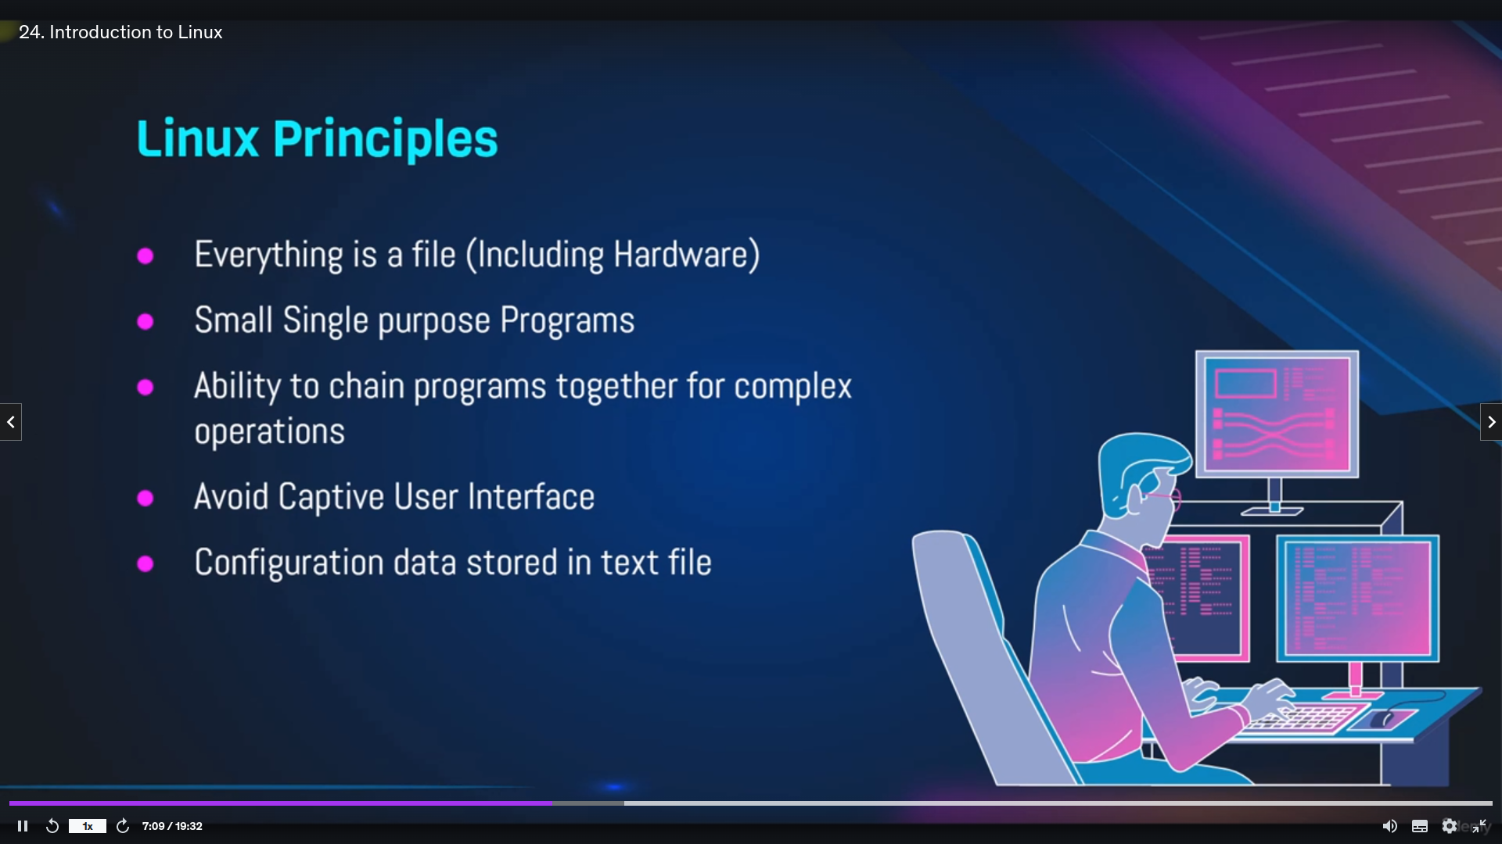for Linux it stores everything in a file format

it doesn't have Graphical interface like windows

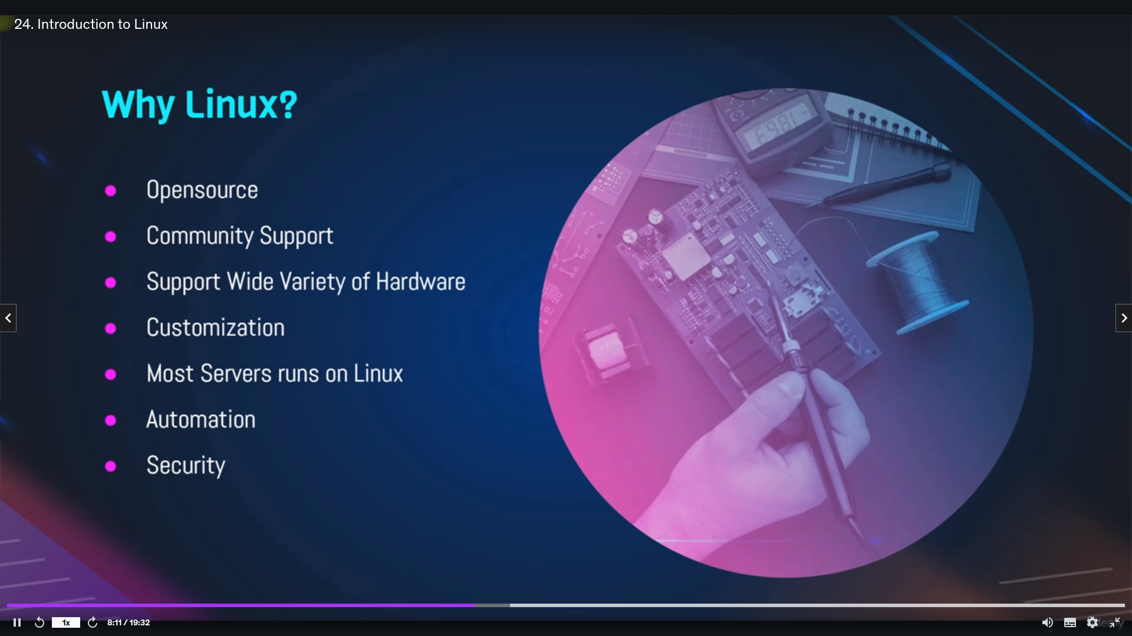

**linux princple :**

[command] [options] [aruguments]

Example:

Command

**ln -s /home/ec2-user/a1/a2/b.txt a1**

here ln is a command which means link

-s is option which means sorted

/home/ec2-user/a1/a2/b.txt : source

a1: destination

source and destination are arguments

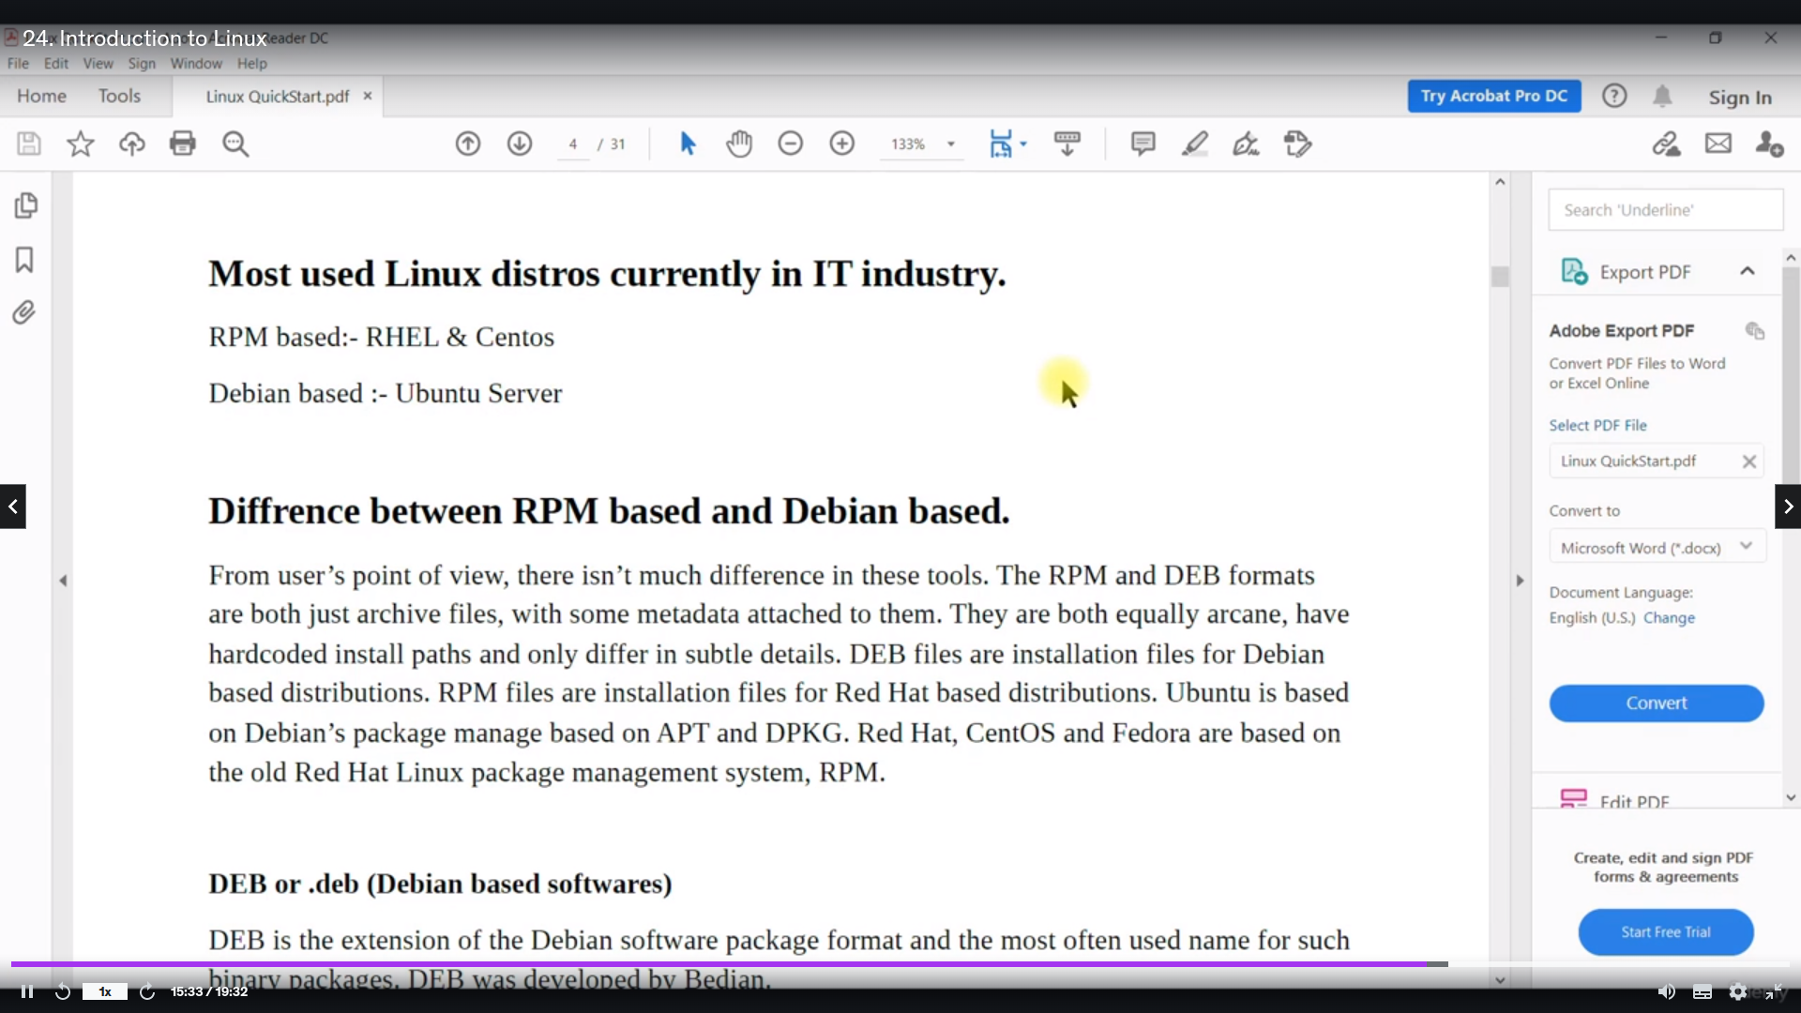

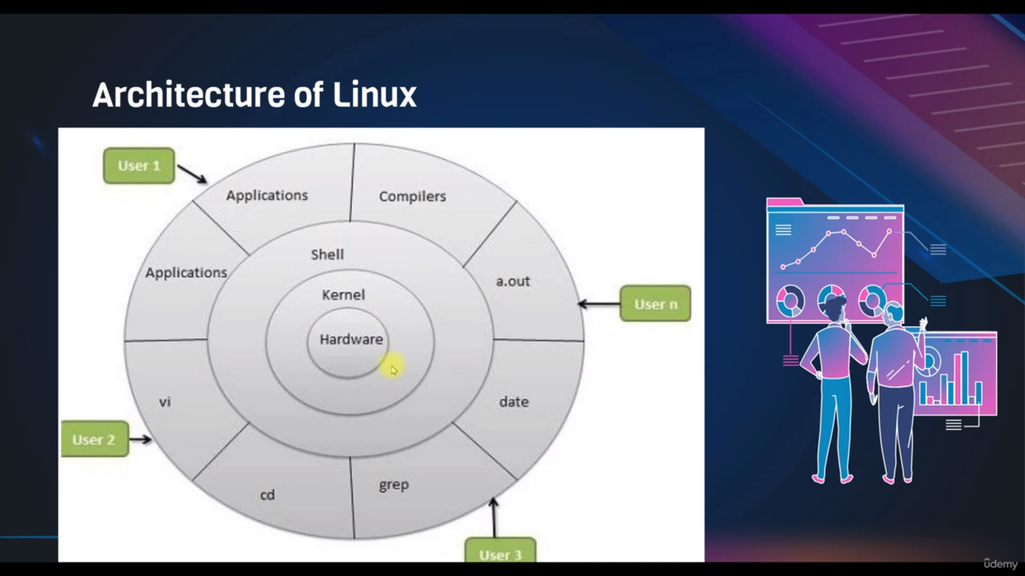In this the user give the commands from shell where the kernel understand the user given commands with [some programs that programs developed by developer] and give instructions to hardware

on top shell we can also install different s/w like vi and some program compilers

d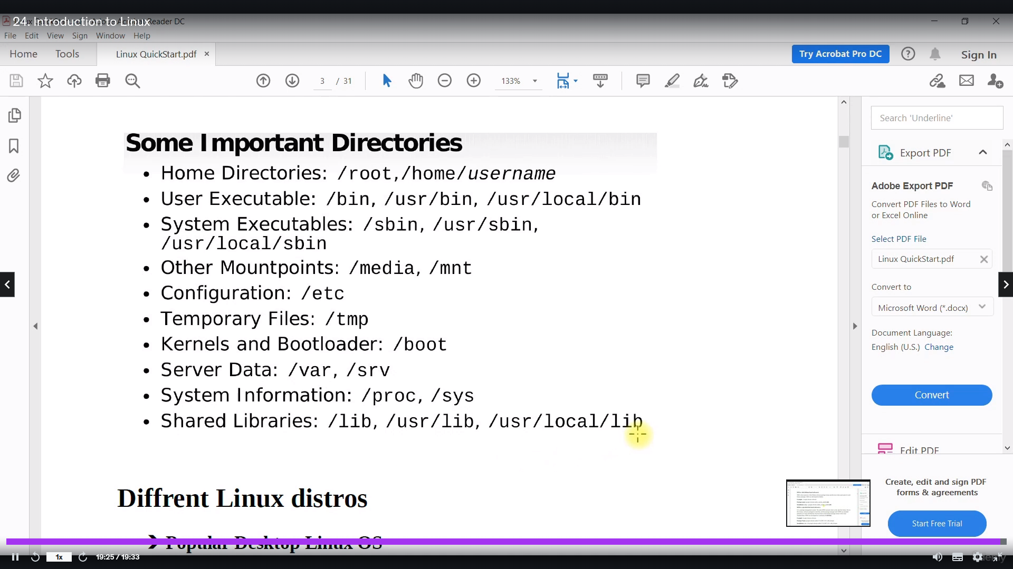irectories:

root can go anywhere and do anything in Linux

/:

it is toplevel directory or root directory

Home:

it is the interface of every user

**for root :/root**

**all user: /*home* /user**

user executable**: /bin*, /usr/bin, /usr/local/bin***

commands like [ls, pwd ,cat] are stored in this directory these are executed by normal user

sytemexecutables: **/sbin*, /usr/sbin, /usr/local/sbin***

Command like [useradd,yum,apt] are stored and these are executed by root user

other mount points: **/media, /mnt**

it is for external devices

Configuration: **/etc**

it is for network configuration,server configuration,user configurations

Temporary files: **/tmp**

it is for temporary files

kernels and boot loader : **/boot**

it is for kernel

Server data: **/var, /srv**

it is for website data,dbserver data like mysql

System Information: **/proc, /sys**

it is for process id and system information

shared libraries: **/lib, /usr/lib, usr/local/lib**

it is for popular libraries

**Prompt:**

**[root@ip-172-31-53-6 /]#**

[**user@hostadress**](mailto:user@hostadress) **directoryname**

**#: indicates its a root user**

**Examples:**

[ec2-user@ip-172-31-53-6 a1]$

here

user: ec2-user

hostadress: ip-172-31-53-6

directoryname- a1

$- it means it is not root user

[ec2-user@ip-172-31-53-6 ~]$: here in place of “a1” “~” is there it indicates that user is in his home directory

Commands:

1 pwd

2 ls

3 whoami

4 cd

5 cd /

6 cd /root

7 ls

8 ls -hltr

9 free -m

10 uptime

expalantion:

1 shows present working directory

2 shows list of all files

3 shows which user is there in shell

4 change the directory

5 it will go the toplevel directory [aboslute path]

6 it will go the root directory [aboslute path]

7 same as 2

8 it shows list of files in a readable format

9 it shows how much ram is used and how much free ram available

10 it shows how many user logged in and how much system is up and run

More Commands:

4 mkdir a{1..2}

6 rm -rf a{1..2}

8 cd tmp

11 mkdir a{1..3}

13 touch b{1..2}.txt a1

16 cp b{1..2}.txt a1

17 ls

18 cp -r a2 a1

19 ls

20 mv b{1..2}.txt a3

21 ls

23 ls

26 mv --help

27 mv a2 a3

28 ls

29 cd a1

30 ls

31 rm *.txt

32 ls

33 rm -rf a2

34 ls

35 cd /tmp/a3

36 ls

37 rm -rf *

Explantion:

4: it will create the two directories a1,a2 in pwd

6: it will remove above directories

11:same as 4 but one more directory a3

13: b1,b2 ends with txt files are created

16: it copies b1,b2 to a1

18: it copies a2 to a1

20 : moves b1,b2 to a3

26: it give all command and description for the “mv“command

27: moves the a2 to a3

31: ends with .txt files are removed

33. removes the a2 directory without asking

37: removes all files

VIM editor

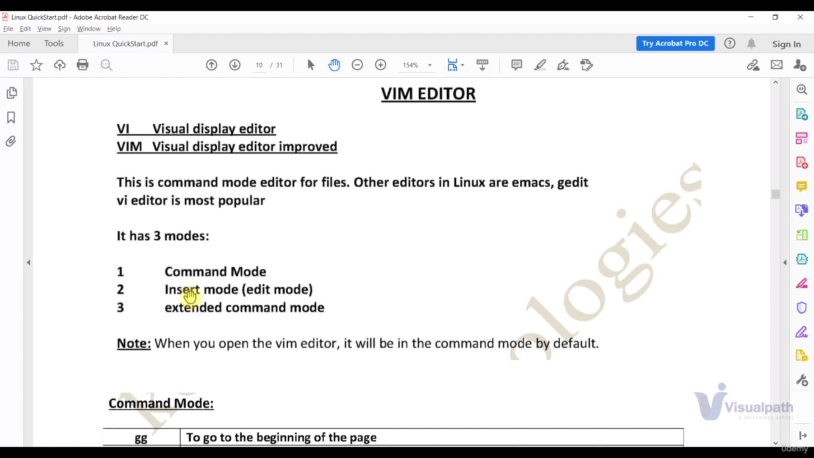

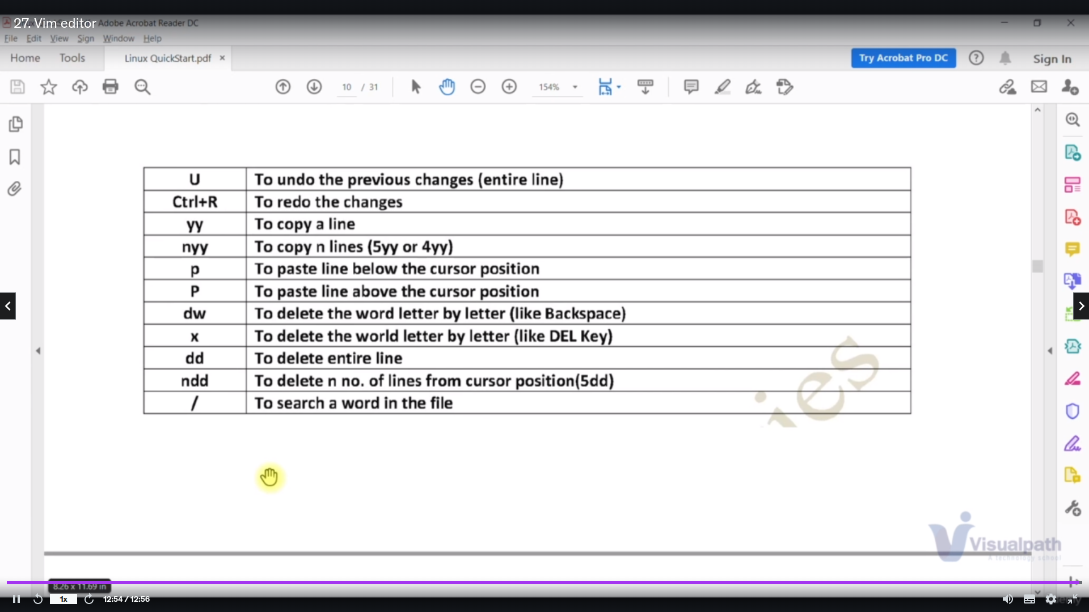

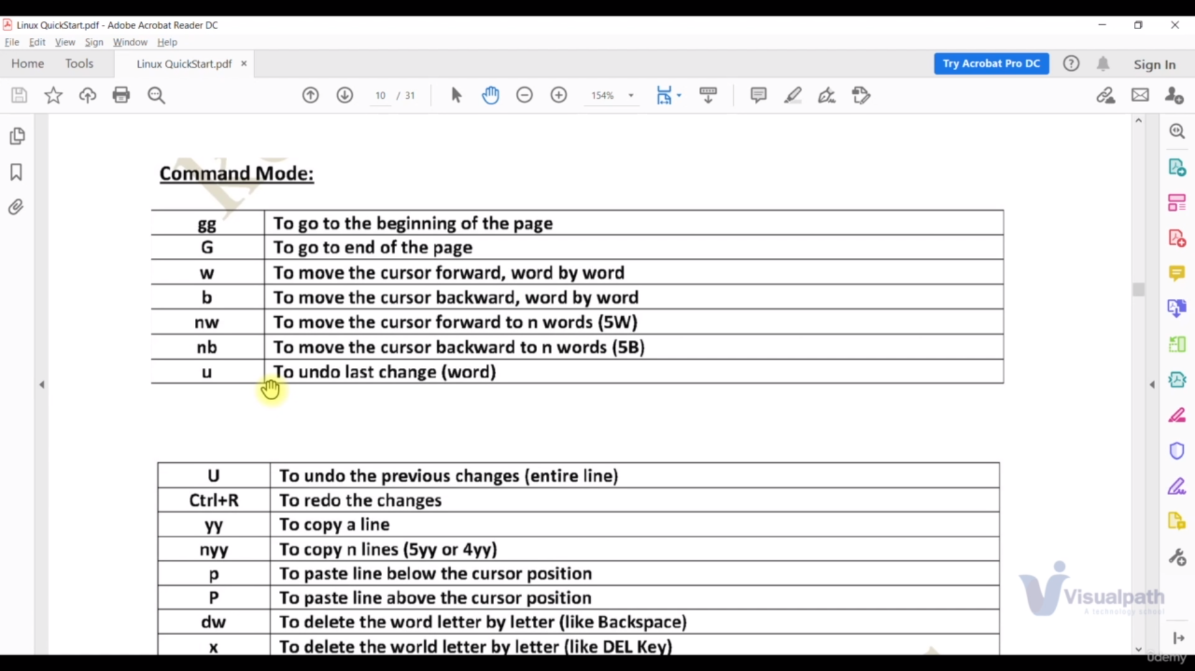

To edit file we have press [insert] key

to save file [esc and after that :wq!]

to not save file of previous changes [esc and after that :q!]

to set the number [: se nu in command mode]

to search [/ {word that you want search} ]

Commands:

86 yum install vim -y

111 vim a2.txt

112 rm a2.txt

117 clear

119 history

Explanation:

86: it installs the vim editor

111 : it is enter into a2. Txt file where we can use those three modes of first image of vim editor

112 removes the a2,txt file

117 it is to clear screen

119 it to show all previous command which are exceuted

**File Types:**

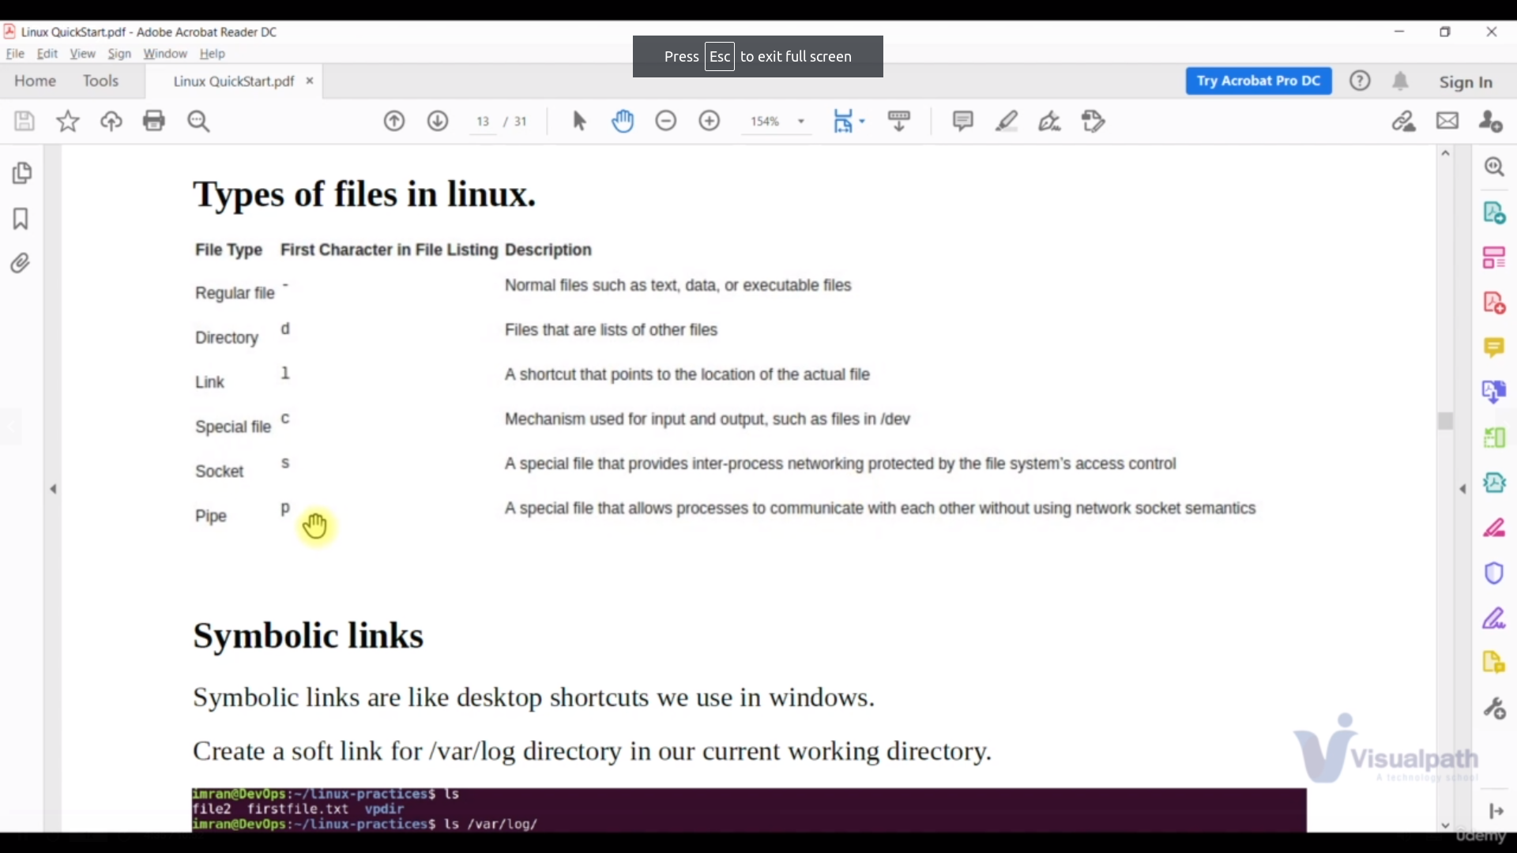examples for above image

c[character file] is used for keyboard

s[socket file] is used for disk files

Commands:

155 mkdir /home/ec2-user/a1/a2

156 mkdir -p /home/ec2-user/a1/a2

160 ln -s /home/ec2-user/a1/a2 a3

163 file a3

164 unlink a3

171 ls

172 ls -l

173 ls -lt

174 ls -ltr

182 cat > /home/ec2-user/a1/a2/b.txt

183 ln -s /home/ec2-user/a1/a2/b.txt a1

185 cat a1

Expalanation:

IN the above 155 is not works because it is we dont have directory a1

for that we user 156

155: not works

156: creates the directory whether file exist or not

160: it will link above created directory with a3

163: it will show the file type

164: it will unlink above created directory with a3

171 it show list of files

172: it show list of files in alphabetical order

173: it show list of files in time stamp[newly created at the top]

173 : it show list of files in time stamp [newly created at the bottom]

182: it will override the b.txt file content with the content what we write

183: it shows the content of the file

**Filters:**

It is used to get the data what we are searching in a file in simplified manner by using filters without giving whole file data.

**grep**

it is used search the line which has the data of what we are searching and grep is case sensitive

Command:

syntax:

grep searchingdata filepath

Examples:

grep Excel /tmp/s.txt

here grep is command

Excel is searching data

/tmp/s.txt file path

other examples;

grep -i Excel /tmp/s.txt

grep -R Excel /tmp/

for grep incasesensitive we use “-i” paramerter

for grep to search all directories file we use “-R” parameter

**less and more:**

it give the user to read the data in flexible than cat command

Examples:

less s.txt

more s.txt

**head and tail :**

it is used to give the first and last 10 line of file by default

syntax:

<command> <parameter> <filepath>

example:

tail -1 s.txt

here

Command: tail

parameter: -1

filepath: s.txt

Examples:

33 head -1 s.txt

34 tail -10 /var/lib/logs

cut:

it is used get data of first row

Command:

cut -d: -f1 /etc/passwd

explantion:

commnad: cut

parameter: “-d” [which means delemiter] “:” [every row is working separated by this] “-f1” [which means first row] “s.txt” [filepath]

examples:

38 cut -d: -f1 /etc/passwd

41 awk -F':' '{print $1}' /etc/passwd

expalanation:

38: it shows first row of file

41: it is used when we want separate the row other than separater like “:”

**search and Replace:**

In vim editor Generally when we want to replace the word we use the command in command mode

Command:

:%s/[searching word]/[replace word/g

serching word: word which we want replace

replace word: this word replaces the searched word

Note: at the end if we dont give “/g” it will only replace the first word of line

Examples:

sed -i "s/sample/simple/g" s.txt

it is the command for replace for multiple files outside the vim editor or in shell command

Note if dont give the “-i” changes are temporary

explanation

33: give first line

34: gives last 10 line

Note for dynamic contentalso these two command works [if we change the filecontent it is automatically reflects]

Commands:

7 grep -R SELINUX /etc/*

8 grep -iR SELINUX /

9 grep -iR SELINUX /*

10 grep -iv network

11 grep -iRv network /etc/*

24 cat > s.txt

25 cat s.txt

26 grep -i Excel /tmp/s.txt

27 grep -iR Excel /tmp/*

28 grep Excel /tmp/s.txt

29 grep -v Excel /tmp/s.txt

30 grep -iv Excel /tmp/s.txt

31 less s.txt

32 head -1 s.txt

33 tail -1 s.txt

34 tail -10 /var/lib/logs

35 tail -10 /var/log

36 tail -10 /var/log/

37 tail -10 /var/log/*

38 cut -d: -f1 /etc/passwd

39 awk -F":" {print $1} /etc/passwd

40 awk -F":" "{print $1}" /etc/passwd

41 awk -F':' '{print $1}' /etc/passwd

42 vim s.txt

43 sed "s/sample/simple/g" s.txt

44 sed -i "s/sample/simple/g" s.txt

45 cat s.txt

**Redirection:**

**Redirection:**

we can send the output whichever file we want

Command:

date > /tmp/s

here when we write only date it will display the date on shell but we are redirecting to “s” file in tmp directory

other Examples:

25 echo "############################################################" >> /tmp/s

26 uptime >> /tmp/s

28 free -m >> /tmp/s

30 df -h >> /tmp/s

**Error:**

whenever we got error since bydefualt we have “1” before redirection symbol in command it show error command on shell.instead of that if we use “2” even error also redirected

Command:

38 free -m 1> /tmp/s

39 freeee -m 1> /tmp/s

40 freeee -m 2> /tmp/s

41 fereee -m &> /tmp/s

42 free -m &> /tmp/s

38: it is redirected to s file

39: command not found is displayed on the shell doesn’t goes to s file

40: above command is redirected to s file

41: it is redirected to s file

42: it is redirected to s file

Note: “&” means both “1” and “2”

**/dev/null:**

if we move or redirect anything to this file it shows nothing in null directory

it is kind of black hole it erase every data of file if we throw into that directory

Commands:

33 cat /tmp/s > /dev/null

34 cat /dev/null

36 cat /dev/null > /tmp/s

33: s file is throwed into null file

34: null shows nothing about s file

36: if we throw null files to our s file even it shows nothing

**pipeline: “|”** it is to combine two commands

Command:

43 cd /etc

44 ls | wc -l

45 cd

46 ls | wc -l

47 wc -l

48 ls /etc | grep host

49 tail /var/lib/messages | grep -i vagrant

50 tail -20 /var/log/messages | grep -i vagrant

51 free -m | grep Mem

52 ls -l | tail

53 ls -l /etc | tail

54 ls -l /etc | head -2

Explanation:

46: the list of files goes to the second command which is used to count the files so it shows the count the no of files are there in the directory

48: the list of files goes to the second command which is used to search text init so show the searched text in list of files

49: same as above it serches from last 10 lines

50: same as above “49” but 20 lines

53: shows last 10 files

54: shows first 20 files

**Find and Locate:**

it is find the text or file or directory for specific directory

Commands:

55 find /etc -name host*

57 locate host

59 updatedb

60 locate /etc host

explanation:

55: it will find the word “host” in all etc directory

57: same as find command but it is not used for real time like when delete the data it shows that data even it is deleted until the db is updated

59: we are updating the db data

**User and Groups:**

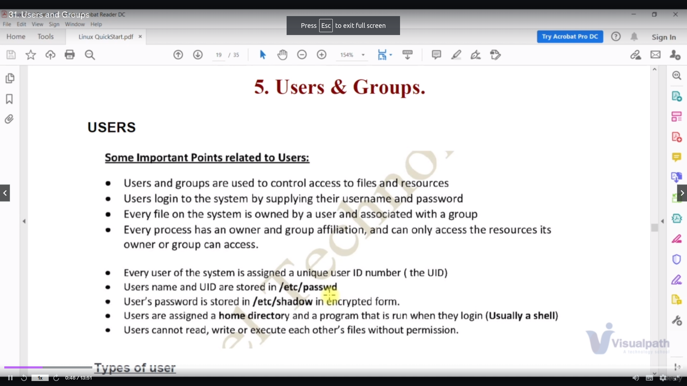

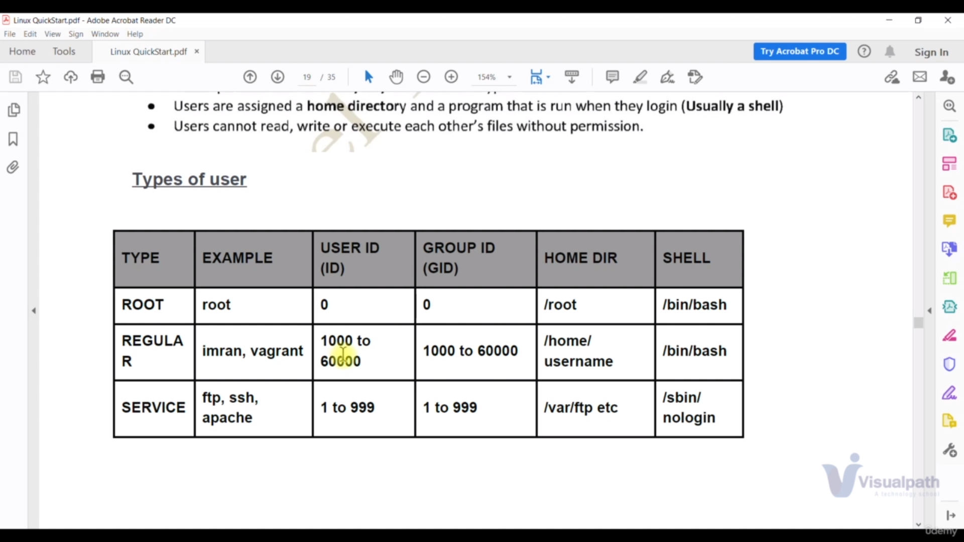

/etc/passwd file: it is the file the user are located

Example:Root user

root:x:0:0:root:/root:/bin/bash

here

root: user

x: link to password file [/etc/shadow]

0: user id

0: group id

/root: home directory

/bin/bash: shell

Example: Normal user

u1:x:1001:1001::/home/u1:/bin/bash

u1: user

x: link to password file [/etc/shadow]

1001: user id

1001: group id

/home/u1: home directory

/bin/bash: shell

Example:systemuser

ftp:x:14:50:FTP User:/var/ftp:/sbin/nologin

ftp: user

x: link to password file [/etc/shadow]

14: user id

50: group id

/var/ftp: home directory

/sbin/nologin: it means it has no shell because on we get the thing we will use for hacking

Command:

id <user>

this command shows groupid userid and all details

Group:

/etc/group: which has the all groups

Example:root

root:x:0:

root: group name

x : link to shadow file

0: group id

Example: Normal user

dev:x:1002:u1

u1: group name

x : link to shadow file

1002: group id

u1: user for dev group

Commands:

**c1:**

**id <user>**

this command shows groupid userid and all details

**c2:**

**usermod -aG dev u1**

this command add the user ‘u1’ to group ‘dev’

here G means secondary group

g means primary group

Note:Another way to add user to group is to edit the file with vim editor

**c3:**

**last**

it show how many user logged in logged off

**c4:**

**lsof -u <user>**

it will give the list of open files that are opened by user

**c5:**

**userdel -r <user>**

it will delete user permanently

**files permissions:**

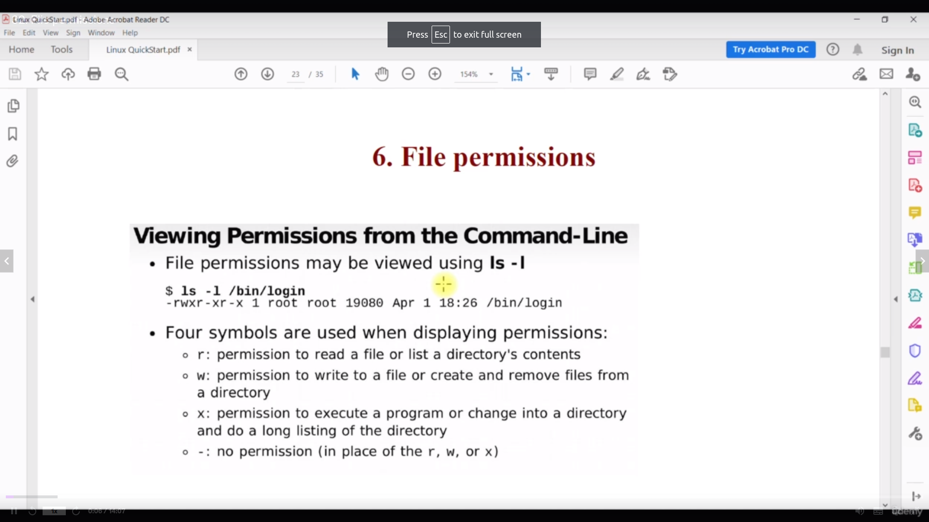

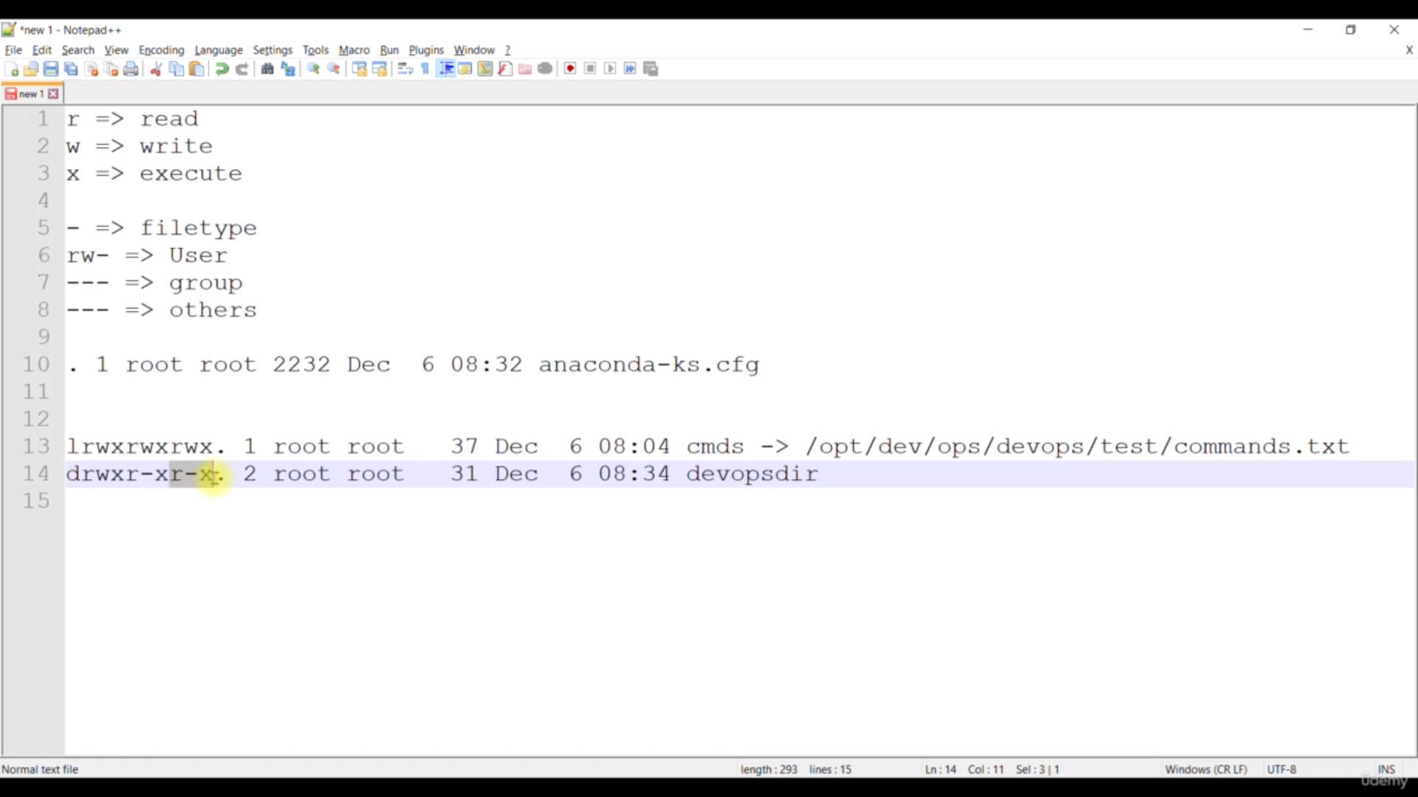

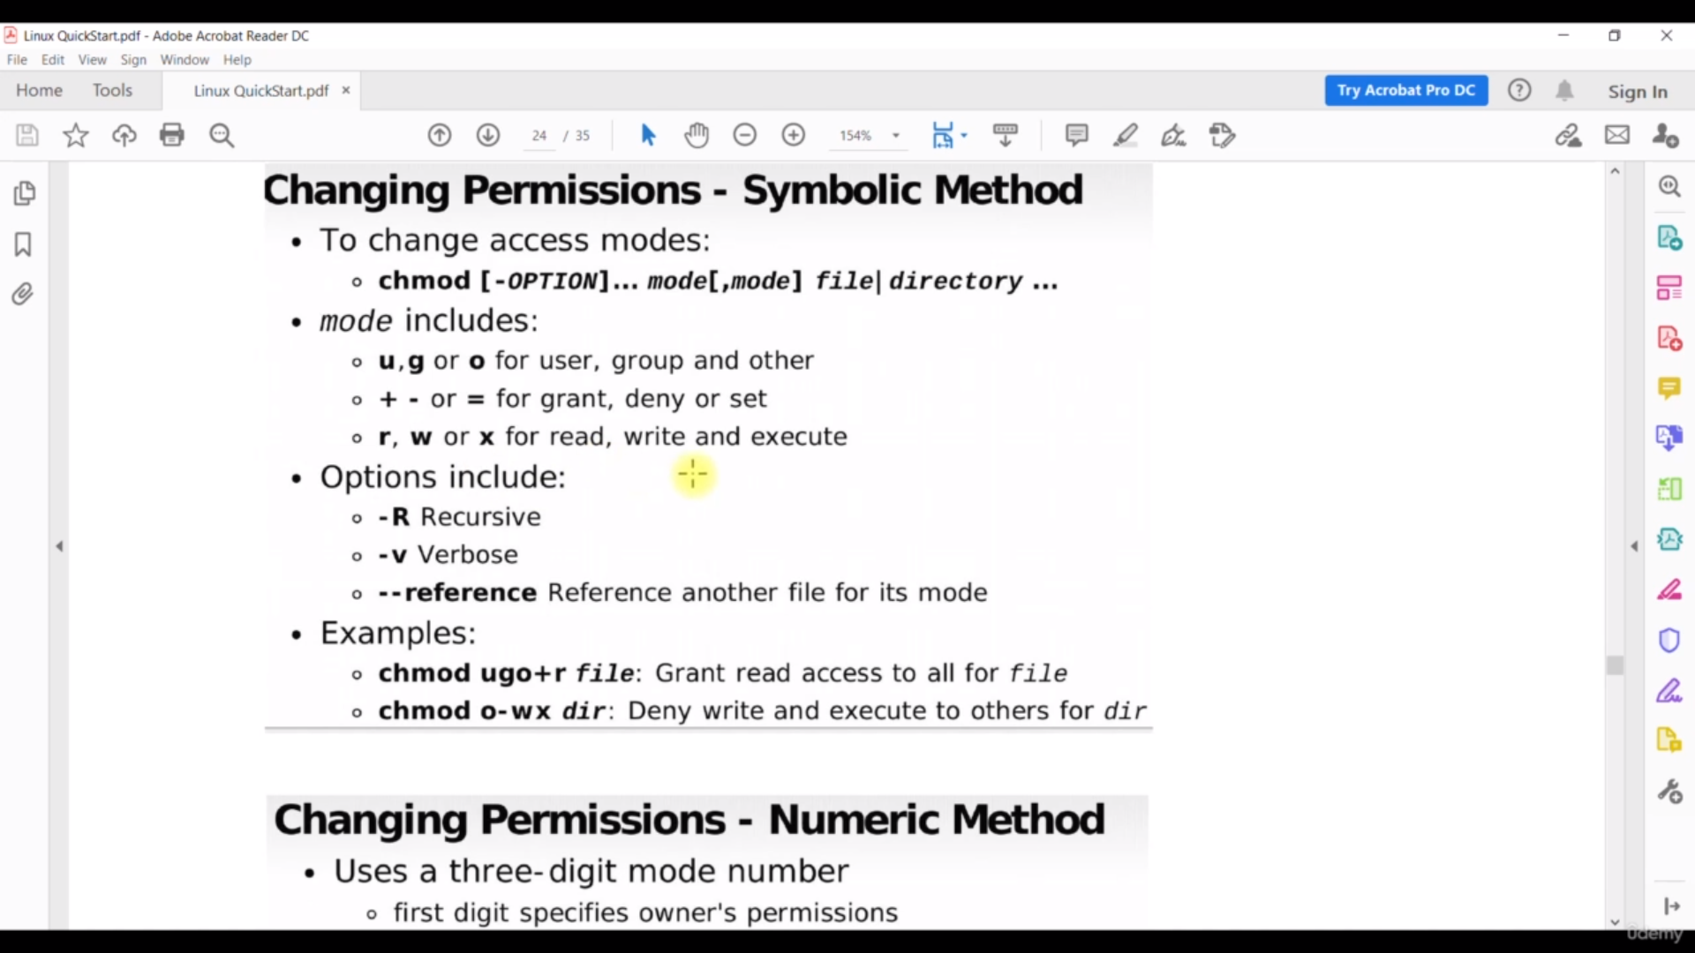

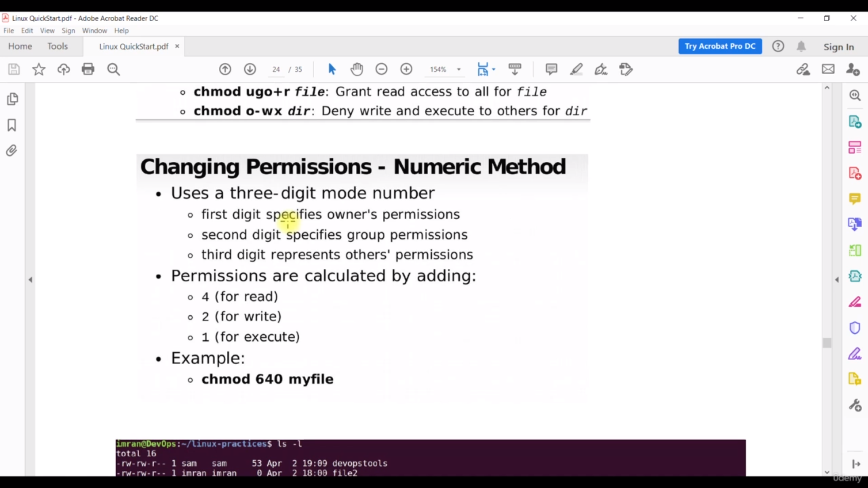

Important Commands:

**chown user:group filename**

it will change user and group for filename

**chmod 777 file name**

it will the permission for all user,group,other also

Note: for more info refer above images.

**Sudoers:**

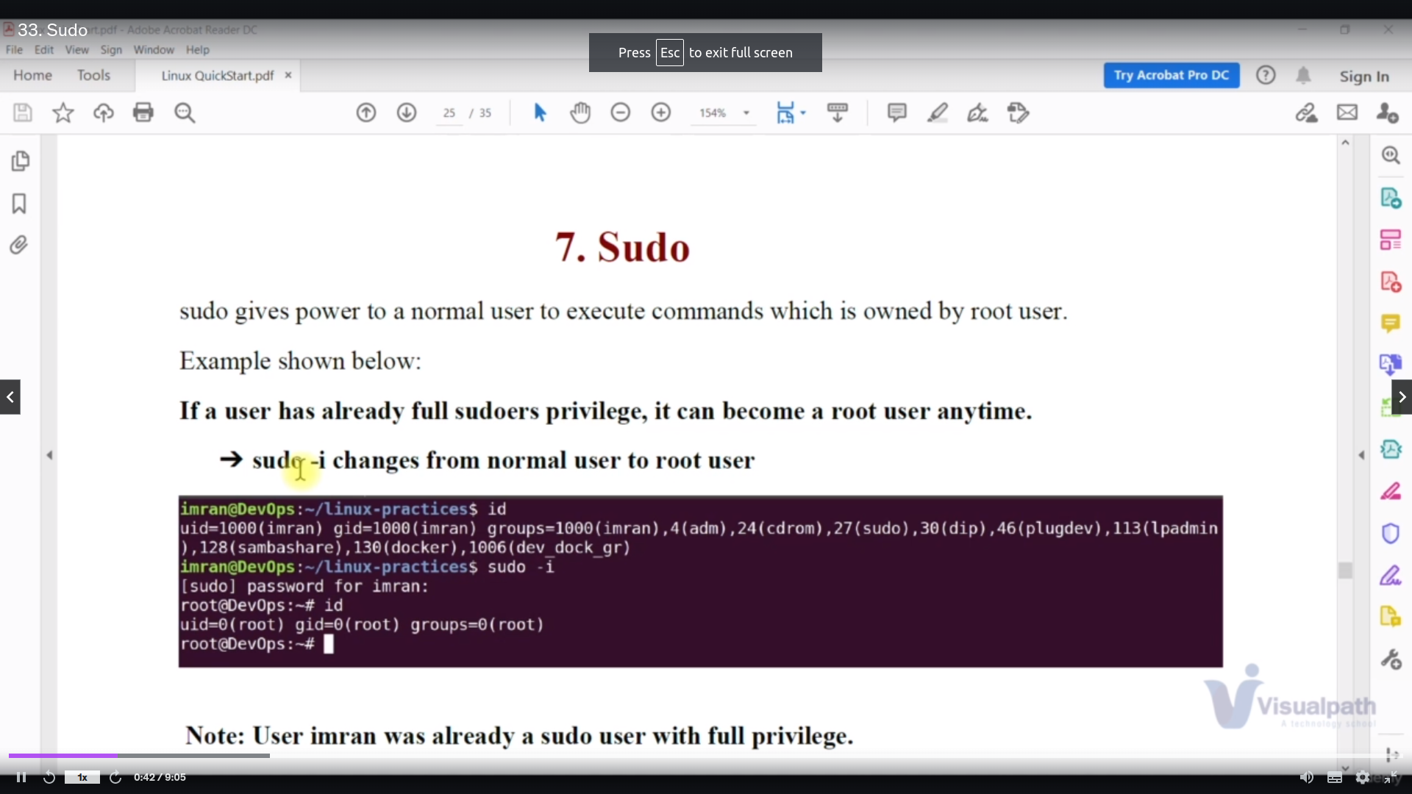

sudo is command which will act as root for normal user

root user has the permission from /**etc/sudoers** file where root user given permission by default

**root ALL=(ALL) ALL**

because of this data the root is powerful .we cannot change /**etc/sudoers** file directly so we have the command

**visudo**

which will give the that we can add normal user

Another way to add normal user add the file in **etc/sudoers.d** diretory

file must be like

**username ALL=(ALL) ALL**

for not to ask password we have to add this data

**username ALL=(ALL) NOPASSWD: ALL**

for groups

**%groupname ALL=(ALL) NOPASSWD: ALL**

**PackageMangement:**

packagemanagement is whenever we want to install the new s/w like tree,vim

we have install packages

**Mannual:**

**curl <package link from google> -o <filepath>**

explanation:get the packges and it output goes to filepath

here

curl to get package

package link has the s/w or code

-o is the output of that s/w

filepath output of the s/w goes to which directory

after the package in File path

we have install using command

**rpm -i <package name from above filpath>**

it means install the package from above filepath where the ouput is located

with package name

**Automated:**

**etc/source.list etc/sourcelist/sourcelist.d**

we have

for redos yum repositery which is located at **etc/yum.repos.d**

for debian apt repositery which is located at **etc/source.list**

**etc/sourcelist/sourcelist.d**

by the command

yum install <package name>

apt install <package name>

we can easily install packages

some packages are not there in repositery then we have get the repositey and try install by using yum

Exmaple:

For jenkins

### Add Jenkins repository to Amazon Linux 2 server

I had stated earlier that we’ll use the package installation method. In this method a package repository is required which can be added by running the following command in the terminal.

sudo tee /etc/yum.repos.d/jenkins.repo<<EOF

[jenkins]

name=Jenkins

baseurl=http://pkg.jenkins.io/redhat

gpgcheck=0

EOF

Import GPG repository key.

sudo rpm --import <https://jenkins-ci.org/redhat/jenkins-ci.org.key>

after that we use

yum install jenkins

**Service:**

service a process which is used start by the user after installing it

Examples:

service: httpd

install httpd

**yum install httpd**

start the sevice

**systemctl start httpd**

if we dont want to restart services again and again we have to enable the service link by caommand

**systemctl enable httpd**

to check the status

**systemctl status httpd**

**Process:**

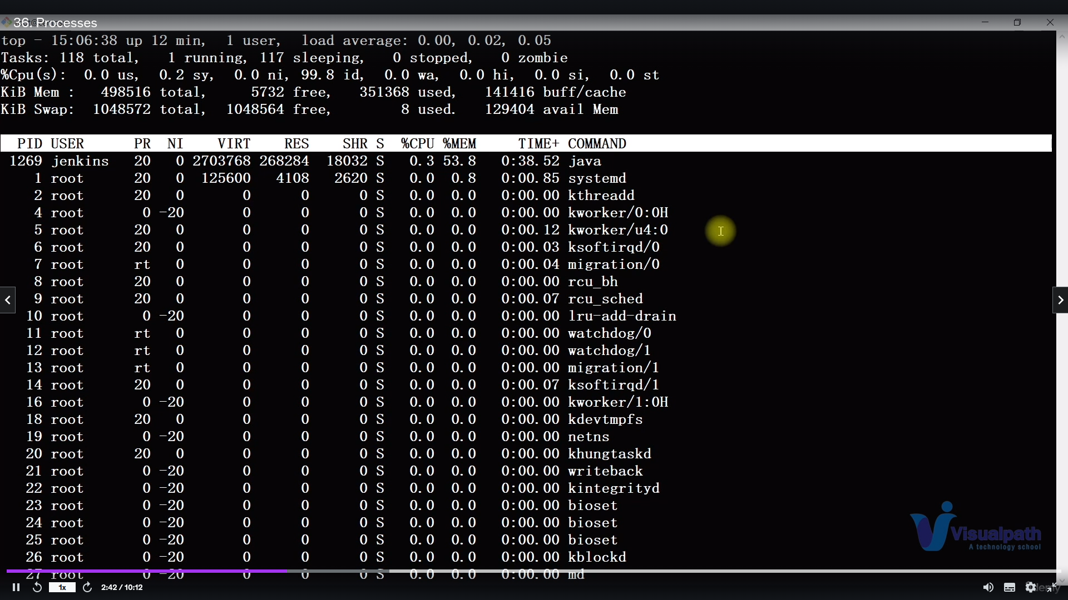shows all dynamic process

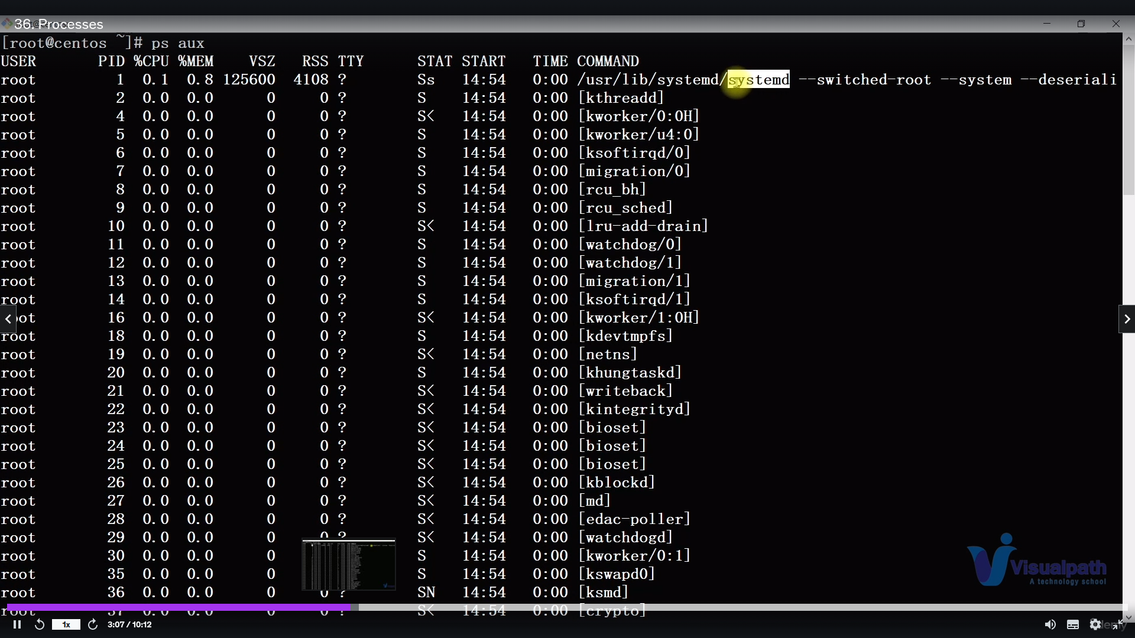showd all static process

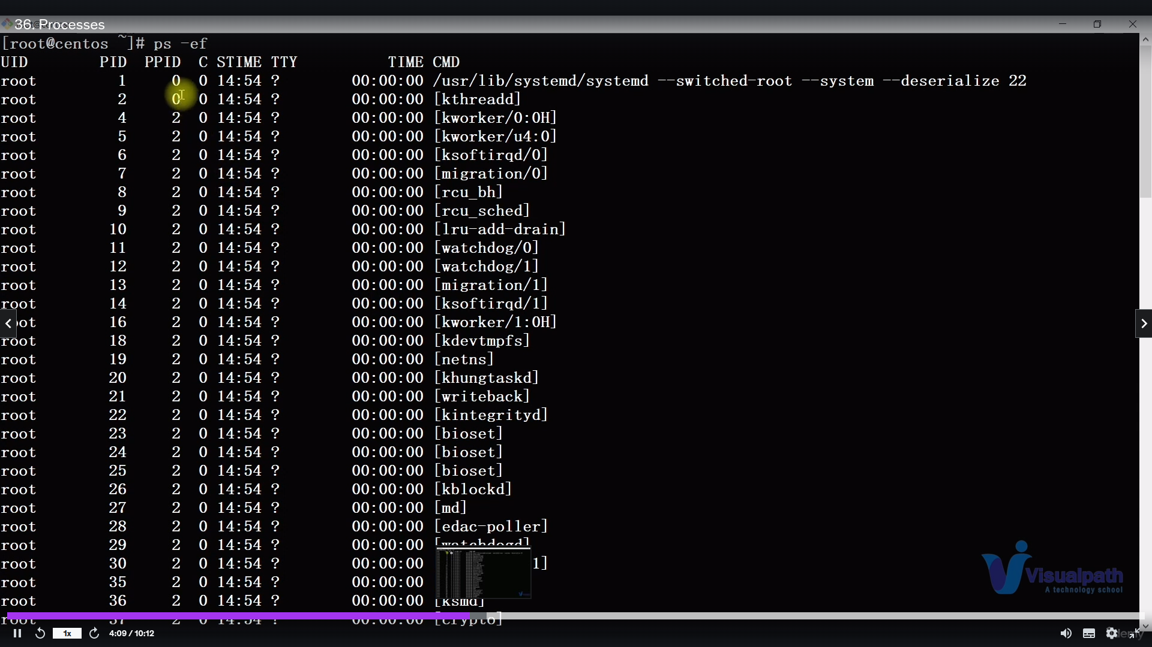shows all parentid but not cpuutilization

**Archieving:**

it is to backup the data

Commands:

**tar -czvf a.tar.gz /root/a**

-czvf: c for create, z is for zip , vf is for verbosfile

a.tar.gz: gz is gunzipping

**tar -xvzf /root/a**

-xvzf: x for exctracting

**zip -r p1.zip p1**

-r for zipping

**unzip p1.zip**

it is for unzipping

**UbuntuCommands:**

ubuntu has the more repository than redhat